Secure Networks

1. Blocking Port 8080 in Windows Defender Firewall :
Since I cannot directly capture a screenshot from your computer, here are the step-by-step instructions to create the rule so you can take the screenshot yourself:
1.Open Windows Firewall:Press Win + R, type firewall.cpl, and press Enter.
In the left-hand pane, click on Advanced settings to open Windows Defender Firewall with Advanced Security.
2.Start New Inbound Rule:Focus on incoming network connections.
Click on Inbound Rules in the left panel, then click New Rule... in the right-hand Actions panel.
3.Configure Rule Properties:Set port, protocol, and block action.
- Rule Type: Select Port and click Next.
- Protocol and Ports: Choose TCP, select Specific local ports, and enter 8080. Click Next.
- Action: Select Block the connection and click Next.
- Profile: Keep all boxes checked (Domain, Private, Public) and click Next.
- Name: Name it Block Port 8080 and click Finish.

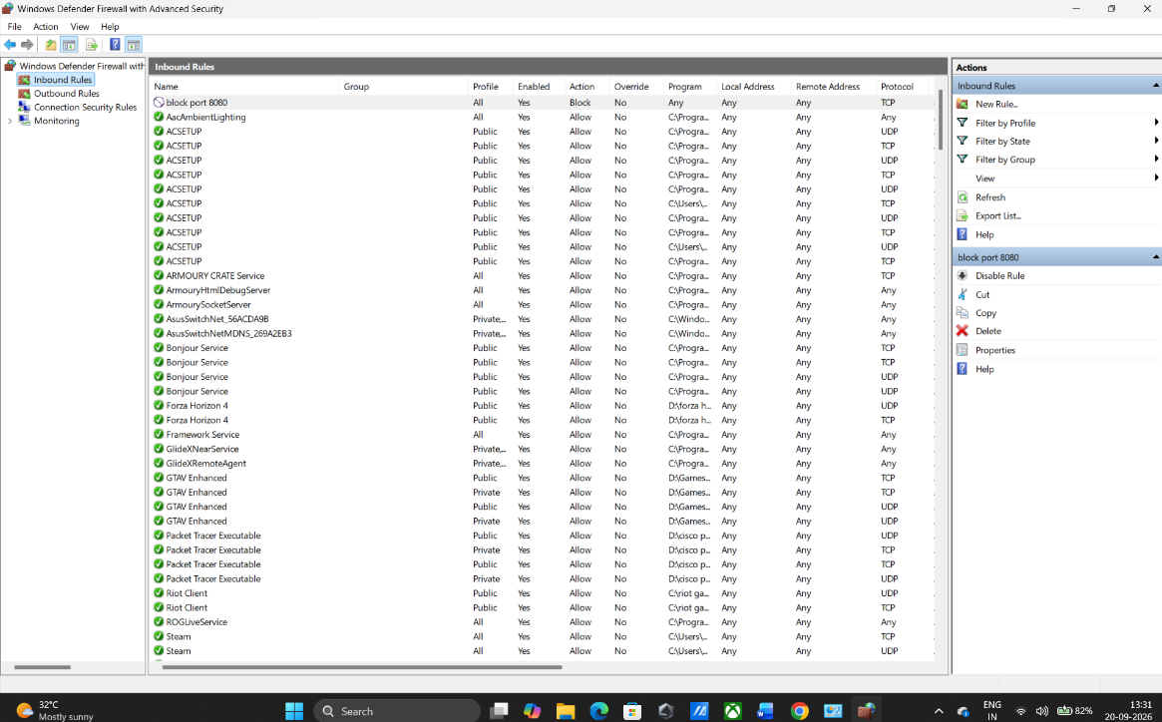

2. NAT (Network Address Translation) Simulation :
Network Address Translation allows multiple devices on your private local network to share a single public IP address assigned by your Internet Service Provider (ISP).
Here is how the IP address mapping works in a typical home setup:
+-----------------+ +--------------------+ +-------------------+
| Home Device | | WiFi Router (NAT) | | Internet / Web |
+-----------------+ +--------------------+ +-------------------+
Phone [192.168.1.2] --+
Laptop [192.168.1.3] --+---> [ LAN: 192.168.1.1 ]
Smart TV [192.168.1.4] --+ [ WAN: 203.0.113.45 ] -------> Public Web Servers
(Translates internal IPs) (See source: 203.0.113.45)
- Private IP Addresses (Local Network):
  - Phone: 192.168.1.2
  - Laptop: 192.168.1.3
  - Smart TV: 192.168.1.4
- Router Public IP (WAN Interface): 203.0.113.45 (Example public IP)
How it works: When your laptop requests a web page, the router swaps the laptop's private IP (192.168.1.3) with its own public IP (203.0.113.45) before sending the data to the internet. When the reply comes back, the router remembers which device asked for it and forwards the data back to 192.168.1.3.
3. Configuring Port Filtering for SMTP (Port 25) :
Router Setup Steps:
- Open a browser and type your router's gateway IP (usually 192.168.1.1 or 192.168.0.1).
- Log in using your admin credentials.
- Navigate to Security / Firewall / Access Control / Port Filtering.
- Create an Outbound Rule setting Protocol: TCP, Port Range: 25, Action: Block / Deny.
Why this prevents spam:
Port 25 is the standard unencrypted port used by mail servers to send emails between each other. Blocking outgoing traffic on port 25 stops malware or infected devices on your network from silently sending mass spam emails behind your back.
4. Packet Filtering Evaluation :

Here is the breakdown of your 3 sample packets:
# | Packet Type | Source IP | Destination IP | Destination Port | Protocol | Common Filtering Outcome
1 | HTTP Request | 192.168.1.5 | 172.217.166.78 | 80 | TCP | Usually ALLOWED (Standard web traffic)
2 | SSH Request | 10.0.0.10 | 34.201.23.1 | 22 | TCP | Restricted / BLOCKED on standard user subnets, ALLOWED only if SSH rule exists
3 | DNS Query | 192.168.1.7 | 8.8.8.8 | 53 | UDP/TCP | Almost always ALLOWED (Required for domain name resolution)
How to verify with your specific trainer's table:
- Check Packet 1: Find a rule matching Port 80 (or HTTP). If the rule action is ALLOW or ACCEPT, it is ALLOWED.
- Check Packet 2: Find a rule matching Port 22 (or SSH). If no rule permits port 22 or if there is an explicit DENY Port 22, it is BLOCKED.
- Check Packet 3: Find a rule matching Port 53 (or DNS). If permitted, it is ALLOWED.
5. How Instagram or Zomato Use Firewalls & Packet Filtering :
- Stopping DDoS Attacks (Volume Control):
  - High-traffic platforms use rate-limiting firewalls to detect when a single IP address sends millions of fake requests in a few seconds. The firewall instantly blocks packets from that suspicious IP so real users can still order food or browse reels without the site crashing.
- Blocking Unwanted Web Traffic (Port Filtering):
  - Databases containing user passwords or order history run on internal ports (like Port 5432 or 3306). Firewalls automatically block any packet coming from the public internet that tries to connect directly to these database ports, allowing only web traffic on Ports 80 and 443.
- Restricting Admin Access (IP Filtering):
  - Important company tools—like Zomato's restaurant management dashboard or Instagram's internal moderation systems—use firewalls that only accept connections from specific, trusted company IP addresses. If a hacker tries to access these admin portals from outside the office network, the firewall drops their packets immediately.

